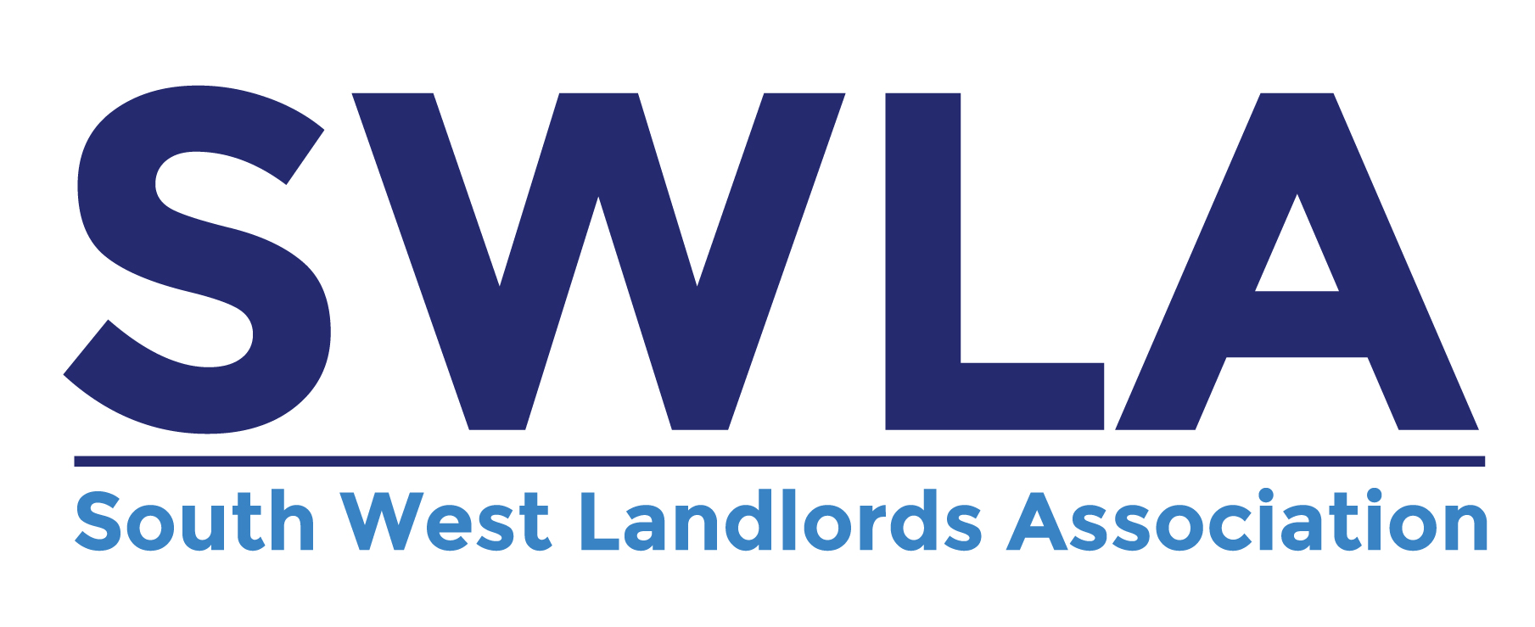

30 Dale Road, Plymouth PL4 6PD
Telephone: 01752 510913 Email: info@landlordssouthwest.co.uk Website: www.landlordssouthwest.co.uk

SWLA’s Guide to the General Data Protection Regulation (GDPR) which came into effect 25th May 2018

GDPR formed the new standard by which landlords and agents deal with personal information from their tenants, prospective tenants, residents and guarantors and any others from whom they collect information. It replaced the Data Protection Act and introduced significant changes to the way you should process personal information.

- If you haven’t done so already, register with the ICO (Information Commissioners Office). It costs £40.00 per year for most landlords. The cost is £35.00 if paid by Direct Debit.

www.ico.org.uk/for-organisations/register/

- Use the ICO’s ‘SME Web Hub’ to learn about GDPR and your responsibilities.

https://ico.org.uk/for-organisations/sme-web-hub/

- Use the following ICO ‘step by step’ guide to review your business and make adjustments in order to comply with GDPR. This includes listing/auditing the personal information that you collect and store.

https://ico.org.uk/for-organisations/sme-web-hub/getting-started-with-data-protection-top-tips-for-beginners/

- You should issue all new/existing tenants/residents, guarantors and prospective tenants with an updated privacy notice. The ICO have a template that you can use.

https://ico.org.uk/for-organisations/sme-web-hub/make-your-own-privacy-notice/

- If you need help and advice, you can contact the ICO helpline on 0303 123 1113 or visit the ICO website to ‘live chat’.

https://ico.org.uk/for-organisations/sme-web-hub/get-support/

