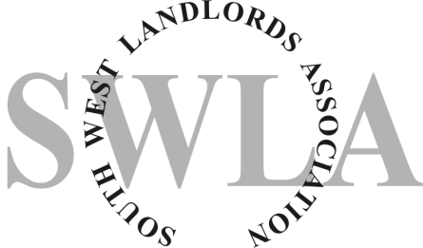
Legionnaires Disease Risk Assessment

Property Address

Date of Assessment
……………………………………………………………………..

Assessment carried out by
………………………………………………………………………

Describe Property Type
………………………………………………………………………

Is there any tenant, resident or regular visitor particularly susceptible to Legionella due to age, health or lifestyle?
.....................................................................................................

Describe type of cold water system e.g. mains feed off from storage tank
……………………………………………………………………….
Describe type of hot water system e.g. mains feed via combi- boiler or from storage tank
………………………………………………………………………..

RISK CATEGORIES
Water Outlet temperature

Is cold water temperature at outlets below 20°C? | Yes/No
Is the hot water temperature above 50°C at outlets? | Yes/No
Cold water must flow from outlets at below 20°C and hot water above 50°C to minimise risk. If temperatures are too high/low then adjustments need to be made to the system such as lagging of pipework or adjustment of settings for hot water.
Identify any defects/risks and related recommendations associated with cold water outlet temperature. If any action is required identify responsible person :-

Defect/risk
Recommendation
Responsible person: Landlord/tenant/other

Cold Water Storage Tanks
Is there one present? | Yes/No
Location
Does it have a tight fitting lid? | Yes/No
Is the water in the tank clean and free from rust, debris, scale and organic matter? | Yes/No
Is the temperature of the water in the tank below 20°C | Yes/No
Is the tank insulated? | Yes/No
If any debris etc. is present in the system it should be drained and thoroughly cleaned. If debris is from corrosion on the tank itself, then the tank may need to be replaced. All cold water tanks should have tight fitting lids to prevent debris entering the system. The water in the tank should be below 20°C and the tank should be insulated to prevent the temperature rising above this level.
Identify any defect/risk and related recommendations associated with cold water storage. If any action is required identify responsible person:-

Defect/Risk
Recommendation
Responsible person: Landlord/tenant/other

Hot Water
Is the temperature setting on the boiler and/or the hot water tank such that the hot water is heated and stored at a temperature of 60°C? | Yes/No
If the temperature is set above 60°C this can cause scalding to the user.
The temperature setting on the boiler and/or hot water tank should be set and maintained at 60°C.
Identify any defect/risk and related recommendations associated with hot water storage. If any action is required identify responsible person:-

Defect/Risk
Recommendation
Responsible person: Landlord/tenant/other

Little Used Outlets
Are there any water outlets that are used less than once per week, for example-a guest bathroom | Yes/No
Any little used outlets should be flushed through weekly by running water through the outlet for a period of at least two minutes. Aerosol production should be minimised during this process.
Identify any risks and related recommendations associated with little used outlets. If any action is required identify responsible person:-

Defect/Risk
Recommendation
Responsible person: Landlord/tenant/other

Shower Heads
Are there any showers in the property? | Yes/No
All shower heads should be thoroughly cleaned, disinfected and descaled at least once every six months. Aerosol production should be minimised during this process.
Identify any risks and related recommendations associated with shower heads. If any action is required identify responsible person:-

Defect/Risk
Recommendation
Responsible person: Landlord/tenant/other

Dead Legs and Redundant Pipework
Sections of pipework which are redundant or owing to the design of the system have little/no flow of water (also known as “dead-legs”) can allow water to stagnate in the system. Are there any dead legs known in the system? If so describe.
Are there any dead legs in the property? | Yes/No  If yes, please identify the location
Any dead legs should be removed or the system amended so that water flows through all the pipework on a regular basis.
Identify any risks and related recommendations associated with dead legs. If any action is required identify responsible person:-

Defect/Risk
Recommendation
Responsible person: Landlord/tenant/other

Unoccupied Properties
Is the property left unoccupied for periods of time, e.g. during the summer months in the case of student lets? | Yes/No
During the period when the property is not occupied all outlets on hot and cold water systems should be flushed through at least once per week for a time of two minutes. For longer periods consider draining the system. Make sure that the system is flushed through when it is re-occupied by running all outlets for at least two minutes. Aerosol production should be minimised during this process.

Identify any risks and related recommendations associated with unoccupancy. If any action is required identify responsible person:-

Defect/Risk
Recommendation
Responsible person: Landlord/tenant/other

Advice to Tenants
Has advice been given to the tenants as to the risks of Legionnaires Disease in a domestic setting and their responsibilities to minimise the risk?  This can be done by giving the tenant(s) the tenant advice sheet | Yes/No
The assessment is complete and should be reviewed regularly (at least once per year) and specifically when there is a reason to suspect that it is no longer valid. You should ensure that the recommendations above are implemented and any existing controls maintained.
Signed | Date
Print Name

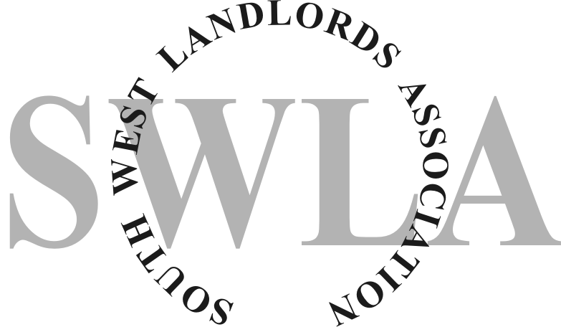

Tenants Advice Sheet – Legionnaires’ Disease

Domestic hot and cold water systems can provide an environment where Legionella bacteria can grow. This can cause Legionnaires’ Disease which can cause a potentially fatal form of pneumonia contracted by inhaling small droplets of contaminated water containing the Legionella bacteria.

This advice sheet gives tips for residents of rented domestic accommodation such as houses, bungalows and flats in small blocks.
Most importantly, you should ensure that:
- Hot water in the system remains hot
- Cold water is kept cold
- Water is kept circulating

It is important that you –do not interfere with the settings on your boiler or hot water system. The hot water should be set so that the water is heated up to 60°C

Tell your landlord if –

* the cold water still runs warm after an initial run-off of any water accumulated in the pipes. It should not be above 20°C.

* there are any problems, debris or discolouration in the water

* the boiler or hot water tank are not working properly, particularly if the water coming out of the taps is not a sufficiently high temperature. The water should come out at a temperature of 50°C after being run for a minute at the latest.

Where showers are fitted –

* if showers are used only occasionally then flush them thoroughly by running them for at least two minutes every week

* clean the shower head periodically, descale and disinfect it. This should be done at least every six months.

Where a property is vacant for any time e.g student accommodation over the summer vacation make sure that when it is occupied again both the hot and cold water systems are flushed through by running all outlets for at least two minutes.

It is your landlord’s responsibility to take precautions to prevent Legionella bacteria being present in the hot or cold water system but tenants and residents have an important role to play in taking these simple and practical precautions.

SOUTH WEST LANDLORDS ASSOCIATION gives notice that whilst this document was in our opinion accurate and suitable for use at the time of printing, SWLA shall not be held liable for the consequences of using this document

