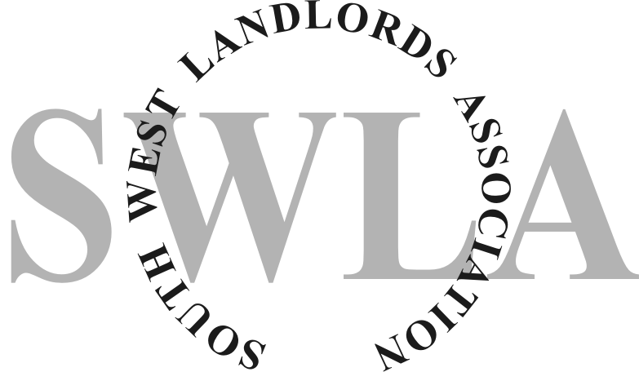
Explanatory Notes
The Regulatory Reform (Fire Safety) Order 2005 places responsibility for Fire Safety in premises on the “Responsible Person”. That is the person who has overall control of the premises. In the case of a residential letting that person is usually the Landlord.
The regulations apply to all premises other than that used as a single domestic dwelling. (There are a few other exceptions but none that would apply in the context of this document)
In the case of residential flats or “Houses in Multiple Occupation”(Bed Sits), the regulations would apply to the common areas but not the individually occupied flat/room. (Although the regulations do not apply to individual domestic flats etc,
consideration must be given to how the common areas are protected from the individual occupancies E.g. Fire Doors/ Fire Alarm)
The regulations require the “Responsible Person” to produce a Fire Risk Assessment that identifies any risks within the premises and any proposed remedial actions.
The Fire Service are the Enforcing Authority and are embarking on a programme of audits. Where there is no Fire Risk Assessment and/or the fire safety provisions are considered inadequate, there are a range of measures they can legally enforce.
The attached is a tool that can be used to carry out a Fire Risk Assessment of your premises. It is recommended that a simple plan of the premises be attached to the completed document.
The Fire Risk Assessment is a live document and should be monitored regularly. It should be reviewed as and when significant changes occur to the premises, but at least annually.
Further guidance can be obtained by clicking on the links in the document or by visiting http://www.communities.gov.uk/fire
Regulatory Reform (Fire Safety) Order 2005 Fire Risk Assessment
Should any of the answers to the following questions be NO then, where applicable, these matters are considered significant as they will undoubtedly impinge upon the effectiveness of the premises fire safety.
These matters will collectively be known as SIGNIFICANT FINDINGS.
Action that requires to be taken to resolve the Significant Findings should be recorded in the REMEDIAL ACTION column on Page 4.
Emergency Lighting

For further guidance:
Is there adequate structural fire safety? (Where Fire doors are installed they should be to an appropriate standard E.g. smoke seals/Intumescent strips/self closing)
Are all self closing fire doors in a good state of repair and operating correctly?
Can all designated fire exits be easily and immediately opened from the inside without the use of a key?
Are all passageways and corridors, both internal and external, which form part of an escape route free from obstructions and storage?
Are all combustible materials, flammable liquids and gases stored safely and isolated from ignition sources?
Are suitable measures in place to protect against the risk of arson?
Is there a satisfactory procedure for the safe evacuation of all persons? (See Fire Safety Signs)
Is the use of extension leads and multi point adaptors kept to minimum?
Is the electrical installation inspected periodically?
Is smoking controlled/prohibited?

For further guidance:
Is the building provided with an emergency lighting system to provide illumination of escape routes in the event of a failure of the general lighting system?
Is the emergency lighting tested regularly?
Are the tests recorded?

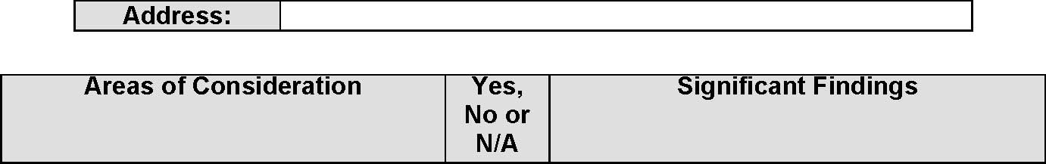
Regulatory Reform (Fire Safety) Order 2005 Fire Risk Assessment
Means of Escape

Means of giving warning in the event of fire

Areas of Consideration | Yes, No or N/A | Significant Findings

For further guidance:
Is there an adequate means of raising alarm in event of fire?
Is the Fire Alarm system in full working order?
Are break glass call points clearly visible and unobstructed?
Is any automatic fire detection system in working order?
Is the alarm audible in all areas?
Is the system tested weekly?
Are the tests recorded?
Is the system regularly maintained?

For further guidance:
Are exit doors and escape routes clearly and correctly signed? (E.g. “Fire Exit” and directional signs to the current standard)
Are all internal fire doors correctly signed? (E.g. “Fire Door Keep Shut” (internal doors) “Fire Door Keep Locked” (cupboards) “Automatic Fire Door Keep Clear” (self explanatory))
Are “Fire Action” signs displayed? (Is each occupant aware of evacuation procedure? Has a copy been handed to them?)

For further guidance:
Are suitable fire extinguishers provided?
Are they securely mounted on wall brackets or sited on appropriate stands?
Are they freely available, visible and unobstructed?
Are they serviced annually by a competent person or company?
Are the results of the annual tests recorded?

Regulatory Reform (Fire Safety) Order 2005 Fire Risk Assessment
Fire Safety Signs
Fire Fighting Equipment

 | Significant Findings | Intended Remedial Action | Time Scale (See Guidance below) | Completed

 | Print Name | Signature | Date
Responsible Person

Regulatory Reform (Fire Safety) Order 2005 Fire Risk Assessment
Guidance to Time Scales:
Issues such as blocked escape routes - IMMEDIATELY
Major work such as Fire Alarm - Six to Twelve Months
Procedural Items such as Notices - One Month
The above is guidance only and time allowed should reflect urgency of action required.
271011

